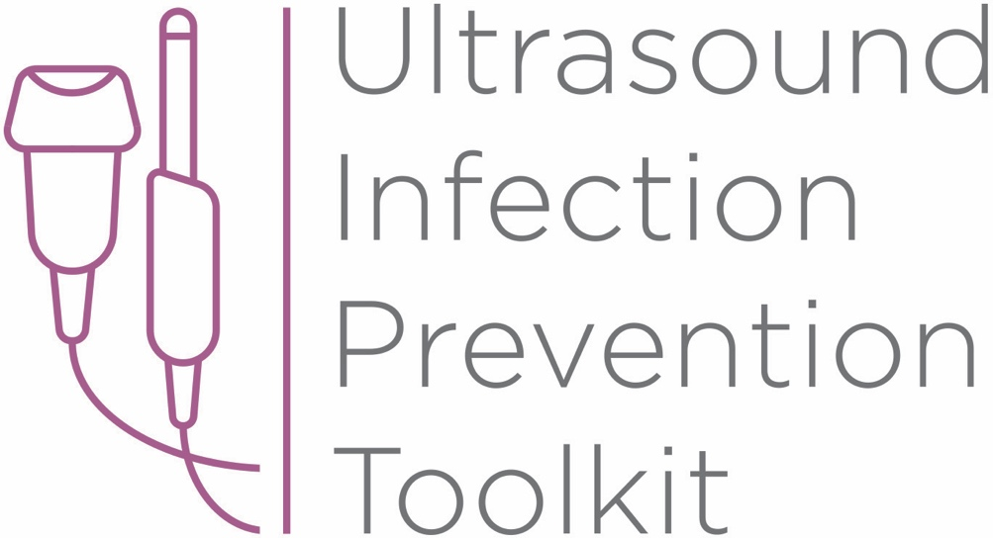

Infection Prevention Toolkit
Prevention of Infection during
Ultrasound Probe Use and Reprocessing
http://www.ultrasoundinfectionprevention.org.au/

Foreword
This Australian toolkit has been adapted from the original U.S. toolkit which was assembled in consultation with clinical experts with backgrounds in infection prevention and instrument reprocessing. The objective in developing this toolkit has been to provide a relevant resource regarding infection prevention during the use and reprocessing of ultrasound probes in Australia.
Australia-specific adaptions have been made by Cathryn Murphy RN Bach. Photog. MPH. PhD. CIC. FAPIC, FSHEA, CICP-E.
The following individuals contributed to the development of the original U.S. toolkit:
Sue Barnes RN CIC FAPIC
Roy Boukidjian MSN PHN CIC
Ruth Carrico PhD DNP APRN FSHEA CIC
Robert Garcia BS MT CIC
Sylvia Garcia-Houchins RN MBA CIC
Amy Nichols RN MBA CIC FAPIC
Rose Seavey MBA BS RN CNOR CRCST CSPDT
John Whelan BSN RN

Approach and Principles
These tools have been assembled based on best practice national standards,¹⁻³ guidelines⁴⁻⁶ and accreditation criteria¹ with the goal of reducing infection risks associated with ultrasound use in the interest of patient safety. Guidelines referenced in this toolkit are evidence based, have been developed with infection prevention representation and have followed a formal guideline development process, including a public comment period. These tools are intended to guide the development of institutional policies and procedures, with an understanding that each institution can vary in the patient groups cared for, settings and the types of care provided.

Toolkit Contents
Tool 1: Part A - Locate
This list of strategies can help locate ultrasound machines in your facility. Locating ultrasound machines can be a challenging task, as they may move around, be uncatalogued, or may be unknown to personnel with responsibility for probe use and reprocessing.
Tool 1: Part B - Profile
After locating ultrasound machines with the Locate tool, this audit tool can be used to observe and assess procedure-specific ultrasound policy and practice. First record the procedure and department, then work through the profile form. The questions guide the user through their policy and an observation checklist is provided to record actual practice. The tool leads the user to an action plan if there is no policy, or if there are discrepancies among policy, practice and guidelines.
Tool 2: Algorithm
This tool is organized by department and provides a range of typical procedures that may be encountered in that department. Probe use and reprocessing requirements based on the NHMRC^{5,6} and ASUM/ ACIPC⁴ guidelines and AS/NZ^{2,3} standards are presented as a decision making algorithm. The flow chart can be printed out and displayed throughout office and procedure rooms, and used as a quick reference chart for healthcare workers to determine whether practice is compliant with available guidelines.
Tool 3: Example Risk Assessment
This tool contains four editable templates designed to guide the assessment of potential hazards that may be encountered during the use and reprocessing (cleaning, disinfection, storage) of ultrasound probes. A sample risk matrix is provided with further instructions for completion. A facility should aim to mitigate all significant harm to the lowest risk rating. If that is not possible, the existing workflow and/or products should be reconsidered.
Tool 4: Policy Development Framework
This tool is a policy development framework designed to help develop infection prevention policies for all settings where ultrasound technology is used and probes are reprocessed. It can be used to develop a universal hospital policy or a department specific policy and has been developed based on major guidelines,⁴⁻⁶ standards¹⁻³ and evidence based scientific literature.
Funding

The development of this toolkit has been supported by Nanosonics Ltd. Nanosonics Ltd strives to improve the safety of patients, clinics, their staff and the environment by transforming the way infection prevention practices are understood and conducted and introducing innovative technologies that deliver improved standards of care.

Important Note

This toolkit contains general guidance. Consider this guidance in light of the user’s own professional advice and specific regulations, guidelines, policies and procedures of each region, institution and department. This tool does not replace manufacturer instructions for use (IFUs) nor does it replace institutional policy/workflows, but it is intended to be used in conjunction with them. This Important Note applies to all parts of this toolkit.

Disclaimer

Nanosonics will not accept responsibility of any kind for reliance on this tool or related materials and opinions including any death or injury to persons. The information, materials and opinions contained here are for general information purposes only, are not intended to constitute legal or other professional advice and should not be relied on or treated as a substitute for specific advice relevant to particular circumstances. We make no warranties, representations or undertakings about the content (including, without limitation, the quality, accuracy, completeness or fitness for any particular purpose of such content). This Disclaimer applies to all parts of this tool and every department.

References
1. Australian Commission on Safety and Quality in Health Care (ACSQHC). National Safety and Quality Health Service Standards.2nd ed. In. Sydney: ACSQHC; 2017.
2. Standards Australia Standards New Zealand. AS/NZS 4187:2014 (Incorporating Amendment No. 1) Reprocessing of reusable medical devices in health service organizations. In. Sydney: SAI Global Limited; 2014.
3. Standards Australia Standards New Zealand. AS/NZS 4815:2006 Office-base health care facilities - Reprocessing of reusable medical and surgical instruments and equipment, and maintenance of the associated environment. In. Sydney: Standards Australia and Standards New Zealand.; 2006.
4. Australasian College of Infection Prevention and Control (ACIPC) and Australasian Society for Ultrasound Medicine (ASUM). Guidelines for Reprocessing Ultrasound Transducers. Australasian Journal of Ultrasound in Medicine. 2017;20(1):30-40.
5. National Health and Medical Research Council (NHMRC). Australian Guidelines for The Prevention and Control of Infection in Healthcare. In. Canberra: Commonwealth of Australia; 2010.
6. National Health and Medical Research Council (NHMRC). PUBLIC CONSULTATION: Draft Australian Guidelines for The Prevention and Control of Infection in Healthcare. In. Canberra: Commonwealth of Australia; 2018.

Infection Prevention Toolkit
Tool 4
Policy Development Framework

This tool is a policy development framework designed to help develop infection prevention policies and to be applied to all settings where ultrasound is used and reprocessed. It can be used to develop a universal hospital policy or a department specific policy and has been developed based on major guidelines, standards and evidence based scientific literature.
Purpose and Scope
This tool has been developed for healthcare personnel developing infection prevention policies for ultrasound probe use and reprocessing. It is an editable document designed as a policy framework for application in all settings where ultrasound is used. This framework can be used to develop a universal hospital policy or a department specific policy. See Instructions.
This tool has been modified to reflect Australian Standards,¹⁻³ guidelines,⁴⁻⁶ and evidence based scientific literature. It is a general document that may need to be modified in line with the specific regulations, guidelines, policies and procedures of each state/ territory, institution and department. All manufacturer instructions for use (MIFU) must be consulted prior to use. This tool covers the following aspects related to ultrasound probe use and reprocessing: cleaning, disinfection/sterilization, storage, ultrasound use (gel, probe covers), responsibilities, education and training.

Instructions
This document is completely editable. Read through each section and modify so that the policy applies to your clinical setting.
When customizing a policy for your facility/department/processes consider the probe models used, ultrasound procedures performed, whether the policy is department specific or hospital wide, and the existing reprocessing workflows currently in use.

Blue boxed text specifies further instructions for each section.

Ultrasound Infection Control Policy
1. Revision History 6
2. Abbreviations 7
3. Scope 7
4. Overview of ultrasound probe reprocessing and use 8
5. Ultrasound probe reprocessing 9
5.1 Cleaning 9
5.2 Disinfection and Sterilization 10
5.2.1 Assigning the Spaulding Classification of the Probe 10
5.2.2 Methods of Disinfection and Sterilization 12
5.2.3 Validation 13
5.2.4 Inadequate Reprocessing 15
5.2.5 Rinsing and Drying 15
5.2.6 Transport & Storage 16
5.2.7 Traceability 17
6. During an Ultrasound procedure 19
6.2 Probe Barriers 19
6.3 Gel Use 20
7. Staff and Responsibilities 21
7.1 Supervisory Personnel 21
7.2 Reprocessing Personnel 21
7.3 Training 22
8. Evaluating changes to products & processes 23
9. References 24

1. Revision History
Date | Revision Number | Change(s) | Reference Section

2. Abbreviations
ACIPC – Australasian College for Infection Prevention and Control
ACSQHC – Australian Commission On Safety and Quality in Healthcare
AS/NZS –Australian/ New Zealand Standard
ASUM – Australasian Society for Ultrasound in Medicine
HLD – high level disinfection
ILD – intermediate level disinfection
IQ – installation qualification
LLD – low level disinfection
PQ – performance qualification
MIFU – manufacturer instructions for use
NHMRC – National Health and Medical Research Council
OQ – operational qualification
PPE – personal protective equipment
SOP – standard operating procedure
TGA – Therapeutic Goods Administration

3. Scope
This policy defines the requirements for ultrasound probe use and reprocessing at [specify facility/department]. All healthcare workers that use ultrasound in procedures, perform the reprocessing of ultrasound probes, and/or oversee the reprocessing and use of ultrasound should be trained and competent in this policy.
‘Ultrasound probe’ refers to external ultrasound probes (e.g., surface, Doppler, linear probes) and non-lumened intracavity probes (e.g., transvaginal, transrectal and transesophageal probes).
Update this Scope to specify facility/department.

4. Overview of ultrasound probe reprocessing and use

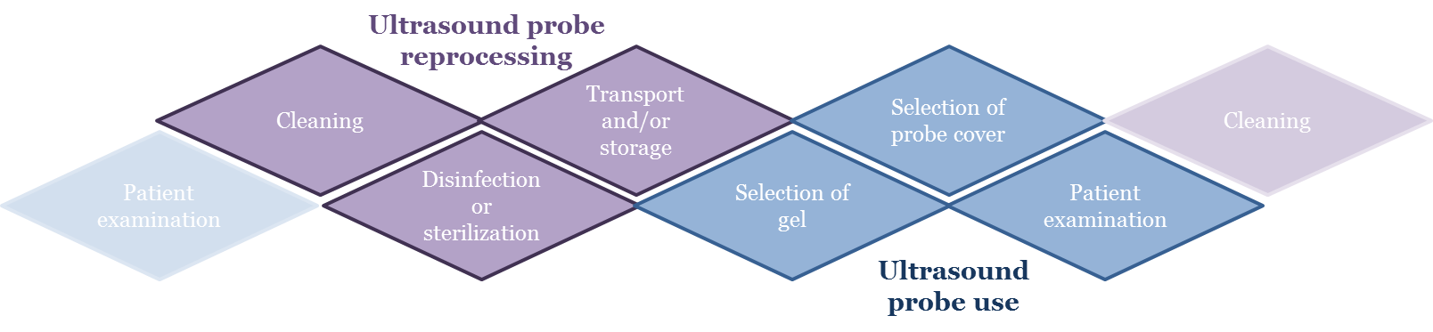
Figure 1. Stages of ultrasound probe reprocessing and use covered in this policy. Traceability needs to be incorporated throughout this process (see Traceability).

The steps in ultrasound probe reprocessing and use are summarized in Figure 1. The steps are probe cleaning, disinfection/sterilization, transport/storage, gel selection, cover selection and patient use. The information in these steps need to be linked (traceability) and responsibilities throughout this process must be clearly defined.
The requirements in this policy relating to ultrasound reprocessing and use have been developed based on the reusable medical device reprocessing requirements in the AS/NZS 4187:2014 (Incorporating Amendment No. 1) Reprocessing of reusable medical devices in health service organizations² and specific ultrasound use and reprocessing requirements in the current edition of NHMRC’s Australian Guidelines for The Prevention and Control of Infection in Healthcare⁵ and the ACIPC/ASUM Guidelines for Reprocessing Ultrasound Transducers.⁴ Where elements relate to facility accreditation, reference is made to the ACSQHC’s National Safety and Quality Health Service Standards 2nd ed.¹
This policy also follows recommendations from the manufacturer instructions for use (MIFUs) of chemical sterilants, high level disinfectants, reprocessing equipment and ultrasound probes used at this facility to ensure compatibility with probe materials.
This policy complies with the following local, state and national regulation/policies [list relevant regulations].
Update this overview to specify relevant regulations and MIFUs.

5. Ultrasound probe reprocessing

5.1 Cleaning
Cleaning is the essential first step in reprocessing. Improper cleaning could render subsequent disinfection or sterilization ineffective. The NHMRC Guidelines define cleaning as “removal of foreign material (e.g. soil and organic material) from objects and is normally accomplished using detergent solution.”⁵ This is generally accomplished manually or mechanically and may include a rinsing step (See ‘Rinsing and Drying’).
Extra care should be taken when cleaning probes that have indentations or complex surfaces. The probe MIFU should always be consulted for cleaning instructions and lists of compatible products. Typical cleaning solutions indicated for use with ultrasound probes include detergent-based cleaning wipes, detergent in combination with running water and enzymatic cleaning agents. The cleaning method should be indicated for use on ultrasound probes, be effective, be compatible with the probe and be safe for the user. Ensure appropriate PPE is available for staff to undertake the cleaning process. Perform rinsing if required by the MIFU of the cleaning product. At the conclusion of the cleaning process, the probe should be dried to prevent interference in subsequent steps.
According to Australian Standards^{2,3} and NHMRC Guidelines⁵ at a minimum, all instruments should be individually inspected and be visibly clean before the device is disinfected or sterilized.
Note the cleaning process used in your department/facility and reference or specify the standard operating procedure (SOP) here.

5.2 Disinfection and Sterilization

5.2.1 Assigning the Spaulding Classification of the Probe
Each ultrasound probe should be classified according to the Spaulding criteria based on its intended use. Medical devices can be classified into three categories based on the patient tissues they contact and associated infection transmission risk. The Spaulding classification system dictates the level of disinfection/sterilization required for the ultrasound probe.²⁻⁶
Non-critical ultrasound probes
- Will only contact healthy intact skin, will not contact mucous membranes, the bloodstream or sterile tissues.
- Require a minimum of low or intermediate -level disinfection (LLD or ILD) with a TGA-registered disinfectant.⁴
- Example procedures where the ultrasound probe is non-critical include abdominal scans on healthy skin and other non-invasive ultrasounds.

Semi-critical ultrasound probes
- Contact mucous membranes or non-intact skin (e.g., skin with abrasions, dermatitis, chapped skin, rash, psoriasis). Semi-critical probes do not contact sterile tissues or the bloodstream.
- Require a minimum of high-level disinfection (HLD)^{4,5} so that the device is free from all microorganisms except for a small number of bacterial spores.
- Example procedures where the ultrasound probe is semi-critical include:
  - Endocavitary ultrasound of healthy mucosa (e.g., transvaginal, transrectal, transesophageal echocardiography scans)
  - Abdominal or other diagnostic scans on non-intact skin
  - Surface wound assessment (e.g., partly healed wound)
- In the event semi-critical ultrasound probes are used in conjunction with a sheath, the probe still requires HLD.^{4,5}

Critical ultrasound probes
- Contact or enter sterile body cavities, sterile tissue or the vascular system.
- Confer high risk for infection transmission if they are contaminated with any microorganism.
- Require sterilization to be free from all viable microorganisms.
- In general, critical ultrasound probes include those used in surgical procedures and some ultrasound guided interventions (e.g., percutaneous procedures where the probe can contact the puncture site). These invasive procedures require a sterile field and sterile instrumentation as they access sterile body sites.
- Standards Australia state specifically that reusable critical medical devices shall be reprocessed to the highest possible level between uses and in accordance with MIFUs.² The ACIPC/ASUM Guidelines⁴ specify that critical ultrasound probes that are delicate and heat sensitive, may be reprocessed by high-level disinfection. However, an appropriate sterile sheath or transducer cover must also be used.

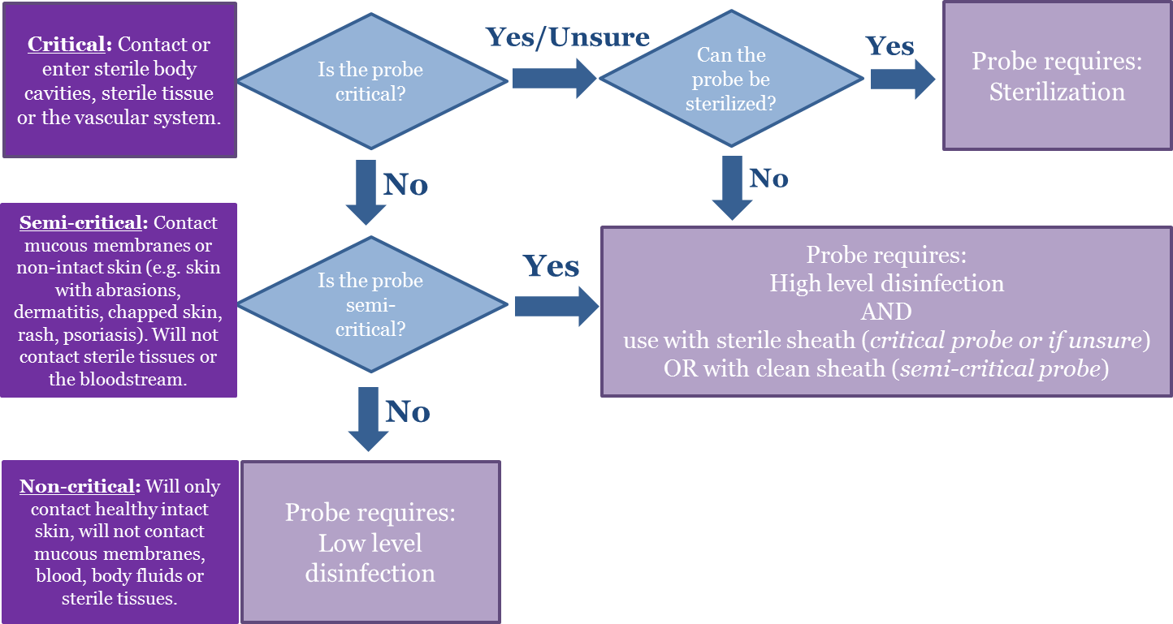
Figure 2. A flowchart decision tree to determine the level of reprocessing and sheath type required before use of an ultrasound probe on a patient.

Apply the above rationale to the procedures used in your department/facility. List the procedures performed and assign the Spaulding classification of the probe and sheath and reference or specify the SOP here.

5.2.2 Methods of Disinfection and Sterilization
Cleaning is a critical requirement prior to any disinfection or sterilization process.^{2,5} It is important to ensure that sterilization or disinfection is compatible with the ultrasound probe such that probe integrity is not compromised. Cleaning agents and instrument-grade HLD methods must be TGA-approved for medical devices and be currently listed on the Australian Register of Therapeutic Goods (ARTG).⁴

Note the disinfection/sterilization process used in your department/facility and reference or specify the SOP here.

5.2.3 Validation
All manual or automated reprocessing steps (cleaning, disinfecting, packing or sterilizing processes) must be validated according to AS/NZS 4187.² This requires an installation qualification (IQ), operational qualification (OQ), performance qualification (PQ) and routine monitoring and control.²
Installation qualification (IQ)
The purpose of IQ is to demonstrate that the equipment supplied to perform reprocessing and the environment in which the equipment is installed (services qualification, e.g. water quality), comply with the manufacturer’s installation specifications.² IQ is undertaken by the supplier of the equipment.²
Operational qualification (OQ)
The purpose of OQ is to demonstrate the capability of the equipment to deliver the reprocessing endpoints defined by the MIFU, and is also undertaken by the manufacturer. This is performed without a load, or with a defined test material. OQ is performed immediately after installation, relocation, modification, service change or repair.²
Performance qualification (PQ)
The purpose of PQ is to demonstrate that reprocessing endpoints are met with device loads intended to be reprocessed by the health service organization. Physical performance qualification (PPQ) and microbiological performance qualification (MPQ) are required to be performed by the organization. PPQ requires validation that critical physical parameters are achieved, and MPQ requires validation of the microbiological lethality of the process. PQ is performed immediately after IQ and OQ, relocation, modification, service change or repair.²
Routine monitoring and control
The purpose of routine monitoring and control is to ensure the validated processes for the device are delivered to the actual device at every reprocessing cycle. Types of monitors are shown in Figure 3. The MIFU should be followed to determine monitor type, frequency, placement and interpretation of results.
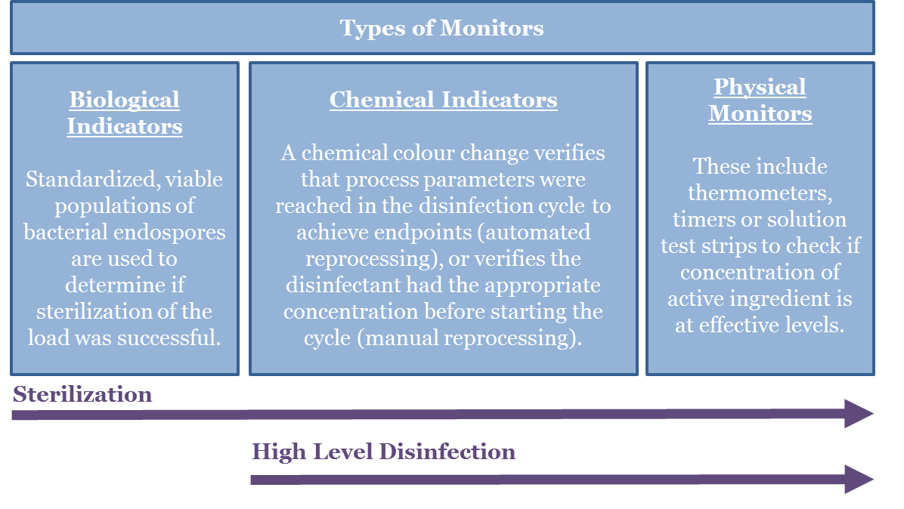
Figure 3. A summary of different types of monitors which can be employed for process validation.

As part of cycle validation, ensure monitor results are documented and stored to facilitate traceability. Also ensure staff are trained regularly in their use and interpretation.^{2,4}

Note the validation processes required in the MIFU for your disinfection/sterilization process and reference or specify the SOP here.

5.2.4 Inadequate Reprocessing
If a reprocessing cycle fails, ensure the probe is not used on the patient and follow the procedure for non-conformance outlined in Section 2.5 of AS/NZS 4187:2014 (Incorporating Amendment No. 1) Reprocessing of reusable medical devices in health service organizations² and Section C4.2.3 Critical incidents in the NHMRC Australian Guidelines for The Prevention and Control of Infection in Healthcare.⁵
In the event of multiple reprocessing cycle failures, the following may provide a pragmatic approach to resolving the issue and ensuring patient safety is not compromised.
1. Refer to the disinfectant/sterilization MIFU to troubleshoot. If troubleshooting unsuccessful, document and report the process/device and nature of failure, and remove from service.

2. Head of department, risk management, or infection control department and others per local protocol should be immediately notified. An investigation should be conducted to assess any patient harm, and decision made regarding patient notification.

3. After the problem is corrected the process/device should be thoroughly validated (via a range of monitors and/or diagnostic cycles) and in accordance with AS/NZS 4187:2014 (Incorporating Amendment No. 1) Reprocessing of reusable medical devices in health service organizations² before being returned to service.

Note disinfection/sterilization process specific steps required in the event of a reprocessing failure at your facility here or reference the SOP.

5.2.5 Rinsing and Drying
Sterilization in terminal barriers does not require any rinsing or drying. For liquid chemical sterilization or high-level disinfection, refer to the MIFU to determine rinsing and drying requirements. Determine the number of rinses (if required), the quality of rinse water that should be used (e.g., potable, deionized, sterile) and drying method (e.g., clean, lint free towel or wipe or air dry).
List requirements here or reference SOP.

5.2.6 Transport & Storage
If the reprocessing workflow requires probe transportation, the following requirements should be met (adapted from ACIPC/ASUM Guidelines)⁴:
- Reprocessing can be performed at the point of care (POC) or in a separate room.
- The products used must be safe to use in that setting.
- If reprocessing is performed in another room, a system for transducer transport must be implemented to ensure dirty and clean transducers remain separated. Ideally the workflow would be uni-directional.
- Separate transport containers for dirty and clean transducers are required.

According to Standards Australia, reprocessed medical devices must be stored in a manner that prevents environmental contamination.² Ideally reprocessed probes can be stored in a specific cabinet or on the console with a clean room manufactured storage cover.
- All items must be stored in a way that that maintains their level of reprocessing.²
- All items must be stored dry.
- The minimum recommended standard for a semi-critical or non-critical probe is that a clean disposable cover is applied to the transducer to mitigate risks from environmental contaminants.^{2,4}

Sterilized items should be protected from contamination and delivered aseptically to the point of use.
Update this section with facility/department specific transportation (if required for the disinfection process used) and storage requirements. Ensure requirements above are addressed and considered. Reference any relevant SOPs.

5.2.7 Traceability
Documentation is essential for retrospective investigations associated with gaps or failures in reprocessing, and outbreaks of infection. Documentation, record keeping and monitoring of chemical sterilization processes and high level disinfection processes is required for traceability and quality control.^{2,4,5}
Data should be recorded as per AS/NZS 4187:2014 (Incorporating Amendment No. 1) Reprocessing of reusable medical devices in health service organizations² and the NHMRC Australian Guidelines for The Prevention and Control of Infection in Healthcare.⁵ The following data should be recorded and linked to the patient the device is used upon:²
2.4.3.2 Traceability records
Traceability systems shall require at a minimum, the identification of the following for each RMD:

(a) High level chemical disinfection—Disinfection process records [see Clause 2.2.3(e)]:
(i) Type of RMD, e.g. trans-rectal ultrasound probe, colonoscope, vaginal probe, endoscope.
(ii) Unique identification number of the RMD, e.g. the serial number.
(iii) Date of cleaning of the RMD and identification of the person responsible.
(iv) Identification of the person responsible for connecting the RMD to the AER or for manual immersion of the RMD in the disinfectant.
(v) Identification of the automated equipment used to process the RMD, e.g.equipment identification number or code (if there is more than one unit in the reprocessing facility).
(vi) Disinfecting process cycle number and date of disinfection.
(vii) Other records, including but not limited to the following:
(A) Disinfectant Type/brand of the disinfectant, batch number, manufacturer’s expiry date, date of decanting/opening of disinfectant and in-use expiry date/date for disposal.
(B) Test strips Brand/type of test strip, batch number, manufacturer’s expiry date, date of decanting/opening of test strips and in-use expiry date/date for disposal, results of any positive/negative controls performed upon opening, results of test strips used for daily MRC or MRC check for each use/cycle; identification of person conducting positive and negative controls and identification of person conducting MRC check.
(C) Cycle process record/printout, self-disinfection cycles (where required), water filter pressures and date of chemical and filter changes.
(D) Manual immersion into disinfectant, temperature of disinfectant, time of immersion into disinfectant, time removed from disinfectant, final rinse according to chemical disinfectant and RMD manufacturers’ instructions.
(viii) Documented evidence of attainment of process parameters, e.g. process
record/printout (where applicable).
NOTE: Process records can be paper based or electronic. Where electronic records are
kept, procedures should be in place to verify attainment of process parameters at the
conclusion of every cycle.
(ix) Identification of the person responsible for release of the RMD.

(b) Sterilization—Sterilizing process records [see Clause 2.2.3(d)]
(i) Date of sterilization and sterilizing process cycle number.
(ii) Identification of the sterilizer, e.g. sterilizer identification number or code (if there is more than one unit in the reprocessing facility).
(iii) Identification of the RMD (e.g. RMD name or name of a set of RMDs) and the number of these items within the load.
(iv) Identification of the person responsible for loading the RMDs into the sterilizer.
(v) Other records, including but not limited to the following:
(A) Results of any performance tests required to verify functional performance of the equipment prior to use, e.g. leak rate test, Bowie and Dick—type test.
(B) Results of chemical and biological monitoring undertaken for individual cycles or on a periodic basis (see also Section 8).
(C) Sterilizing agent (where applicable), batch number and expiry date.

(vi) Documented evidence of attainment of process parameters, e.g. process record/printout (where applicable).
NOTES:
1 Process records can be paper based or electronic. Where electronic records are
kept, procedures should be in place to verify attainment of process parameters at
the conclusion of every cycle.
2 Additional information can be linked to an RMD where an electronic traceability
system is in place. These systems can assist in other management activities
including asset management.
(vii) Identification of the person responsible for release of the RMD (sterilization load).

Update this section with your disinfection/sterilization process and workflow specific traceability process. Ensure above requirements are met and specify methods and information that needs to be collected, linked, stored and maintained.

6. During an Ultrasound procedure

This section expands on probe barrier use and specifies gel use requirements based on the Spaulding classification of the ultrasound probe. This rationale should be applied to each procedure in your facility/department and specified.
6.1 General
It is important to ensure all equipment necessary for the procedure is adequately reprocessed before use. Additionally, proper protocols should be used to prevent cross-contamination between surfaces, probes, operators and the patient.
It is also important to remember that unexpected changes in patient circumstances may occur and will require considering whether the selected probe is still appropriate for the upcoming procedure. For example, the patient may present with non-intact skin (e.g., dermatitis, rash or wound) when intact skin was expected. This would make the probe semi-critical instead of non-critical and will consequently require HLD versus LLD.
See Disinfection and Sterilization for assigning the Spaulding classification to the probe.

6.2 Probe Barriers
Probe sheaths (e.g., dedicated covers, condoms) are an additional layer of protection to prevent excessive soiling and to minimize the chance of cross contamination between patients. Sheaths are available sterile and non-sterile (usually clean-room manufactured). Condoms are typically non-sterile.
NHMRC and ACIPC/ASUM guidelines require semi-critical probes (e.g. intracavity probes) to undergo high level disinfection and be used with a single use sheath.^{4,5} They require critical probes undergo sterilization, and if this is not possible, the probe should minimally undergo HLD and be used with a sterile sheath.⁴
Studies have demonstrated the high frequency of probe sheath perforation rates, occurrences of probe sheath contamination post procedure and difficulties involved with visually determining probe sheath breaches and perforations.⁷⁻¹³ Standards Australia state that:
“Single use sheaths/ sleeves/ protective barriers...shall not be used as a substitute for cleaning, disinfection or sterilization.”^{2,3}
See Disinfection and Sterilization for assigning the Spaulding classification to the probe and the associated cover use.

6.3 Gel Use
Ultrasound coupling gel is necessary to allow passage of the ultrasound energy into patient tissues and is required for a good quality image. It is used in almost all ultrasound procedures. As such, policy describing safe handling and use is paramount to reducing and preventing cross contamination. Numerous outbreaks from contaminated ultrasound gel have been reported in the literature.¹⁴⁻¹⁸ In some cases these infections have been associated with invasive procedures such as ultrasound guided central venous catheter placement, pericardiocentesis, amniocentesis and surgeries. Gel is typically available in single-use sachets (sterile and non-sterile) as well as in non-sterile multi-use gel bottles. Careful selection of the correct type of gel is important for preventing infections. A rationale for sterility requirements for gel use can be derived from the Spaulding classification. For critical and semi-critical items, sterile gel should be used, for non-critical a minimum of multi-use gel can be used (Table 2).⁴
After completion of the procedure, the probe should be immediately cleaned and all visible gel and bioburden removed before subjecting the probe to subsequent reprocessing steps. Relevant staff should be educated regarding the use of probe covers and ultrasound coupling gel and competency regularly checked.

Table 2. Ultrasound gel use during ultrasound guided procedures
Critical probes | Semi-critical probes | Non-critical probes
Sterile single use gel | Sterile single use gel | Multiuse, non-refillable gel acceptable
Considerations | Considerations | Considerations
Use aseptic technique when handling  Sterile single use gel is the minimum requirement for invasive procedures where there is risk of the probe and gel contacting sterile tissue and blood or where an aseptic field is in use. | Use aseptic technique when handling  Sterile single use gel is the minimum requirement for procedures where there is risk of the probe and gel contacting intact mucous membranes or non-intact skin. | Avoid multiuse gel where possible, single use gels preferred.  If used, care should be taken not to touch the patient or probe with the tip of the multi-use gel bottle.  Discard multiuse bottles based on facility policy and MIFU.  Refillable bottles should be avoided due to established risk of bacterial growth.  Generally gel warming should not be used due to the risk of pathogen growth.
General considerations (all gel)
- Ensure gel is only used within its shelf life
- Store gel protected from sources of contamination (e.g., dust, moisture)
- Check before use for visual evidence of contamination

7. Staff and Responsibilities
The levels of staff and corresponding reprocessing responsibilities may vary depending on the size and structure of healthcare facilities. According to Standards Australia and the NHMRC, assigning responsibility is important for accountability and effective patient safety.^{2,5}

7.1 Supervisory Personnel
Supervisory personnel oversee all reprocessing and use activities described in this policy. Standards Australia recommends they are trained in instrument reprocessing; participate in continuing education programs on management (personnel, material, financial) and leadership; participate in other courses related to the management position, with special emphasis on infection prevention and control, safety, and the principles and methods of reprocessing. Supervisory personnel should also have knowledge of relevant local, state and federal regulations and relevant qualifications (e.g., reprocessing certification).²
Specify supervisory personnel (profession level) at your facility/department here.

7.2 Reprocessing Personnel
Processing personnel should have documented competence in relevant cleaning methods and microbiocidal processes and equipment related to the specific sterilization/HLD process used in the department. Furthermore, they should have knowledge of general sterilization/disinfection and infectious disease transmission principles and aspects of liquid/chemical sterilization/HLD (if relevant), such as:
- Reprocessing
- Inspection of cleaning, drying and rinsing processes,
- Monitoring of sterilization/HLD processes,
- Maintaining documentation for traceability purposes,
- Safety with regard to using the equipment and personal hygiene, and,
- Use of PPE (where relevant) to protect skin, eyes, mucus membranes and clothing. ^{2,5}

Processing personnel are also required to participate in ongoing training programs which focus on orientation into the healthcare facilities and their departmental policies, infection prevention and control, use of reprocessing equipment, safety, attire, personal hygiene and compliance with local, state and national regulations.
Specify reprocessing personnel (profession level) at your facility/department here.

7.3 Training
Staff involved in reprocessing and ultrasound equipment usage should receive orientation training prior to commencing responsibilities. Additionally, annual re-training should be performed for the duration of their employment. Training should establish the knowledge base required to safely perform reprocessing, safely use ultrasound in procedures, with the goal of removing operator error, promoting staff and patient safety and ultimately mitigating infection transmission risks.^{2,4,5}
Each facility should have documentation of training, competence and qualifications for staff involved in reprocessing.²
Specify training requirements and schedule here.

8. Evaluating changes to products & processes
All aspects of this policy should be reviewed with infection prevention and other relevant subject matter experts when setting up the use of ultrasound for the first time, purchasing new ultrasound equipment or making changes to existing processes. Additional considerations are:
Safety – The NHMRC guidelines and Australian Standards require staff and patient safety must not be compromised by the chosen reprocessing workflows and processes.^{2,5} Consider chemical exposure risks from bulk liquids and vapors. Work area design considerations must be assessed (e.g., ventilation, designated dirty/clean sinks, hazardous waste disposal units, emergency showers) if required.
Cost –Cost-effectiveness factors that should be evaluated related to equipment (e.g., purchase, service and maintenance), consumables, PPE, energy, disposal costs and training).
Reprocessing time – Consider time required to examine patients versus time for reprocessing. If there is high patient turnover it may be necessary to change the reprocessing procedure or purchase additional probes for effective turnaround time.
Reprocessing location – If probes are reprocessed at point of use, then the disinfection method must be safe for patients and staff. Standards Australia and ASUM/ACIPC Guidelines require a dirty to clean workflow during reprocessing.^{2,4} This should be observed regardless of reprocessing location with designated dirty and clean areas to prevent cross contamination. If transport of dirty or clean devices is required to a central reprocessing area, then a probe transportation protocol must be observed to prevent mixing of dirty and clean instruments (See Transport and Storage).
Automated or manual reprocessing – Consideration should be given to automated versus manual processes. It is well accepted that automated processes minimize the influence of human factors on reprocessing outcomes and should be adopted where possible.¹⁹

9. References
1. Australian Commission on Safety and Quality in Health Care (ACSQHC). National Safety and Quality Health Service Standards.2nd ed. In. Sydney: ACSQHC; 2017.
2. Standards Australia Standards New Zealand. AS/NZS 4187:2014 (Incorporating Amendment No. 1) Reprocessing of reusable medical devices in health service organizations. In. Sydney: SAI Global Limited; 2014.
3. Standards Australia Standards New Zealand. AS/NZS 4815:2006 Office-base health care facilities - Reprocessing of reusable medical and surgical instruments and equipment, and maintenance of the associated environment. In. Sydney: Standards Australia and Standards New Zealand.; 2006.
4. Australasian College of Infection Prevention and Control (ACIPC) and Australasian Society for Ultrasound Medicine (ASUM). Guidelines for Reprocessing Ultrasound Transducers. Australasian Journal of Ultrasound in Medicine. 2017;20(1):30-40.
5. National Health and Medical Research Council (NHMRC). Australian Guidelines for The Prevention and Control of Infection in Healthcare. In. Canberra: Commonwealth of Australia; 2010.
6. National Health and Medical Research Council (NHMRC). PUBLIC CONSULTATION: Draft Australian Guidelines for The Prevention and Control of Infection in Healthcare. In. Canberra: Commonwealth of Australia; 2018.
7. Masood J, Voulgaris S, Awogu O, Younis C, Ball AJ, Carr TW. Condom perforation during transrectal ultrasound guided (TRUS) prostate biopsies: a potential infection risk. International urology and nephrology. 2007;39(4):1121-4.
8. Amis S, Ruddy M, Kibbler CC, Economides DL, MacLean AB. Assessment of condoms as probe covers for transvaginal sonography. J Clin Ultrasound. 2000;28(6):295-8.
9. Milki AA, Fisch JD. Vaginal ultrasound probe cover leakage: implications for patient care. Fertil Steril. 1998;69(3):409-11.
10. Storment JM, Monga M, Blanco JD. Ineffectiveness of latex condoms in preventing contamination of the transvaginal ultrasound transducer head. South Med J. 1997;90(2):206-8.
11. Rooks VJ, Yancey MK, Elg SA, Brueske L. Comparison of probe sheaths for endovaginal sonography. Obstet Gynecol. 1996;87(1):27-9.
12. Hignett M, Claman P. High rates of perforation are found in endovaginal ultrasound probe covers before and after oocyte retrieval for in vitro fertilization-embryo transfer. J Assist Reprod Genet. 1995;12(9):606-9.
13. Fritz S, Hust MH, Ochs C, Gratwohl I, Staiger M, Braun B. Use of a latex cover sheath for transesophageal echocardiography (TEE) instead of regular disinfection of the echoscope? Clinical Cardiology. 1993;16(10):737-40.
14. Olshtain-Pops K, Block C, Temper V, et al. An outbreak of achromobacter xylosoxidans associated with ultrasound gel used during transrectal ultrasound guided prostate biopsy. J Urol. 2011;185(1):144-147.
15. Nannini EC, Ponessa A, Muratori R, et al. Polyclonal outbreak of bacteremia caused by Burkholderia cepacia complex and the presumptive role of ultrasound gel. Braz J Infect Dis. 2015;19(5):543-545.
16. Cheng A, Sheng WH, Huang YC, et al. Prolonged postprocedural outbreak of Mycobacterium massiliense infections associated with ultrasound transmission gel. Clin Microbiol Infect. 2016;22(4):382 e381-382 e311.
17. Shaban RZ, Maloney S, Gerrard J, et al. Outbreak of health care-associated Burkholderia cenocepacia bacteremia and infection attributed to contaminated sterile gel used for central line insertion under ultrasound guidance and other procedures. American Journal of Infection Control. 2017;45(9):954-958.
18. Abdelfattah R, Aljumaah S, Alqahtani A, Althawadi S, Barron I, Almofada S. Outbreak of Burkholderia cepacia bacteraemia in a tertiary care centre due to contaminated ultrasound probe gel. Journal of Hospital Infection. 2018;98(3):289-94.
19. Ofstead CL, Wetzler HP, Snyder AK, Horton RA. Endoscope reprocessing methods: a prospective study on the impact of human factors and automation. Gastroenterology nursing : the official journal of the Society of Gastroenterology Nurses and Associates. 2010;33(4):304-11.

