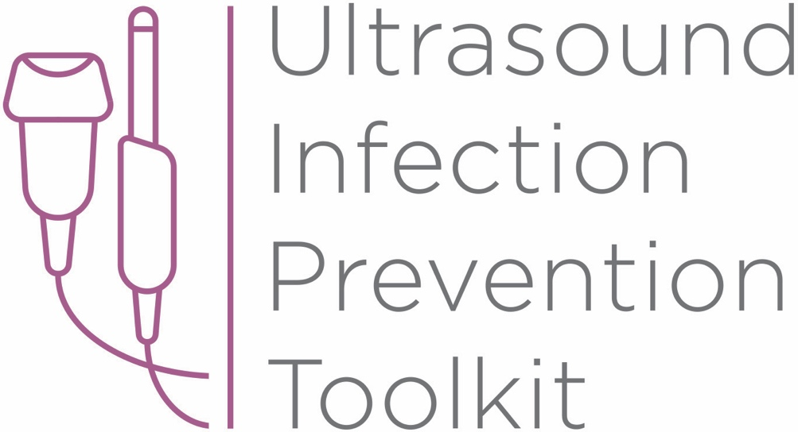

Infection Prevention Toolkit
Prevention of Infection during
Ultrasound Probe Use and Reprocessing
http://www.ultrasoundinfectionprevention.org.au/

Foreword
This Australian toolkit has been adapted from the original U.S. toolkit which was assembled in consultation with clinical experts with backgrounds in infection prevention and instrument reprocessing. The objective in developing this toolkit has been to provide a relevant resource regarding infection prevention during the use and reprocessing of ultrasound probes in Australia.
Australia-specific adaptions have been made by Cathryn Murphy RN Bach. Photog. MPH. PhD. CIC. FAPIC, FSHEA, CICP-E.
The following individuals contributed to the development of the original U.S. toolkit:
Sue Barnes RN CIC FAPIC
Roy Boukidjian MSN PHN CIC
Ruth Carrico PhD DNP APRN FSHEA CIC
Robert Garcia BS MT CIC
Sylvia Garcia-Houchins RN MBA CIC
Amy Nichols RN MBA CIC FAPIC
Rose Seavey MBA BS RN CNOR CRCST CSPDT
John Whelan BSN RN

Approach and Principles
These tools have been assembled based on best practice national standards,¹⁻³ guidelines⁴⁻⁶ and accreditation criteria¹ with the goal of reducing infection risks associated with ultrasound use in the interest of patient safety. Guidelines referenced in this toolkit are evidence based, have been developed with infection prevention representation and have followed a formal guideline development process, including a public comment period. These tools are intended to guide the development of institutional policies and procedures, with an understanding that each institution can vary in the patient groups cared for, settings and the types of care provided and regulatory and licensing requirements.

Toolkit Contents
Tool 1: Part A - Locate
This list of strategies can help locate ultrasound machines in your facility. Locating ultrasound machines can be a challenging task, as they may move around, be uncatalogued, or may be unknown to personnel with responsibility for probe use and reprocessing.
Tool 1: Part B - Profile
After locating ultrasound machines with the Locate tool, this audit tool can be used to observe and assess procedure-specific ultrasound policy and practice. First record the procedure and department, then work through the profile form. The questions guide the user through their policy and an observation checklist is provided to record actual practice. The tool leads the user to an action plan if there is no policy, or if there are discrepancies among policy, practice and guidelines.
Tool 2: Algorithm
This tool is organized by department and provides a range of typical procedures that may be encountered in that department. Probe use and reprocessing requirements based on the NHMRC^{5,6} and ASUM/ ACIPC⁴ guidelines and AS/NZ^{2,3} Standards are presented as a decision making algorithm. The flow chart can be printed out and displayed throughout office and procedure rooms, and used as a quick reference chart for healthcare workers to determine whether practice is compliant with available guidelines.
Tool 3: Example Risk Assessment
This tool contains four editable templates designed to guide the assessment of potential hazards that may be encountered during the use and reprocessing (cleaning, disinfection, storage) of ultrasound probes. A sample risk matrix is provided with further instructions for completion. A facility should aim to mitigate all significant harm to the lowest risk rating. If that is not possible, the existing workflow and/or products should be reconsidered.
Tool 4: Policy Development Framework
This tool is a policy development framework designed to help develop infection prevention policies for all settings where ultrasound technology is used and probes are reprocessed. It can be used to develop a universal hospital policy or a department specific policy and has been developed based on major guidelines,⁴⁻⁶ standards¹⁻³ and evidence based scientific literature.

Funding

The development of this toolkit has been supported by Nanosonics Ltd. Nanosonics Ltd strives to improve the safety of patients, clinics, their staff and the environment by transforming the way infection prevention practices are understood and conducted and introducing innovative technologies that deliver improved standards of care.

Important Note

This toolkit contains general guidance. Consider this guidance in light of the user’s own professional advice and specific regulations, guidelines, policies and procedures of each region, institution and department. This tool does not replace manufacturer instructions for use (IFUs) nor does it replace institutional policy/workflows, but it is intended to be used in conjunction with them. This Important Note applies to all parts of this toolkit.

Disclaimer

Nanosonics will not accept responsibility of any kind for reliance on this tool or related materials and opinions including any death or injury to persons. The information, materials and opinions contained here are for general information purposes only, are not intended to constitute legal or other professional advice and should not be relied on or treated as a substitute for specific advice relevant to particular circumstances. We make no warranties, representations or undertakings about the content (including, without limitation, the quality, accuracy, completeness or fitness for any particular purpose of such content). This Disclaimer applies to all parts of this tool and every department.

References
1. Australian Commission on Safety and Quality in Health Care (ACSQHC). National Safety and Quality Health Service Standards.2nd ed. In. Sydney: ACSQHC; 2017.
2. Standards Australia Standards New Zealand. AS/NZS 4187:2014 (Incorporating Amendment No. 1) Reprocessing of reusable medical devices in health service organizations. In. Sydney: SAI Global Limited; 2014.
3. Standards Australia Standards New Zealand. AS/NZS 4815:2006 Office-base health care facilities - Reprocessing of reusable medical and surgical instruments and equipment, and maintenance of the associated environment. In. Sydney: Standards Australia and Standards New Zealand.; 2006.
4. Australasian College of Infection Prevention and Control (ACIPC) and Australiasian Society for Ultrasound in Medicine (ASUM). Guidelines for Reprocessing Ultrasound Transducers. Australasian Journal of Ultrasound in Medicine. 2017;20(1):30-40.
5. National Health and Medical Research Council (NHMRC). Australian Guidelines for The Prevention and Control of Infection in Healthcare. In. Canberra: Commonwealth of Australia; 2010.
6. National Health and Medical Research Council (NHMRC). PUBLIC CONSULTATION: Draft Australian Guidelines for The Prevention and Control of Infection in Healthcare. In. Canberra: Commonwealth of Australia; 2018.

Infection Prevention Toolkit
Tool 2
Algorithm
This tool is organized by department and provides a range of typical procedures that may be encountered in that department. Probe use and reprocessing requirements based on Australian standards,¹⁻³ ASUM/ACIPC guidelines⁴ and the current and draft editions of the NHMRC guidelines^{5,6} are presented as a decision-making algorithm. The printable flow chart can be displayed throughout office and procedure rooms as a quick reference chart for healthcare workers to determine whether practice is compliant with available guidelines.
This tool can also be used in conjunction with Tool 1: Part B – Profile to determine whether policy and practice comply with best practice recommendations.
Guidelines
The following tool is based on the Spaulding classification system which is referenced in the NHMRC^{5,6} and ASUM/ACIPC⁴ guidelines and AS/NZ Standards.^{2,3} The Australian Commission on Safety and Quality in Health Care National Safety and Quality Health Service Standards 2nd ed.¹ refer to these documents for accreditation of health care facilities.
The Spaulding classification system dictates the level of disinfection or sterilization a medical device should be subjected to, based on the degree of infection risk involved with its use and contact sites in patients. The definitions below are drawn from NHMRC,^{5,6} TGA, Standards Australia^{2,3} and ASUM/ACIPC⁴:
Non-critical devices – only contact intact patient skin but not mucous membranes or sterile tissue. This includes non-invasive ultrasound probes. If decontamination is necessary, they require low-level disinfection (LLD) or intermediate-level disinfection (ILD) with a TGA registered disinfectant after cleaning.
Semi-critical devices – contact intact mucous membranes or non-intact skin but not sterile tissue. This includes intracavity ultrasound probes (e.g. transvaginal probes) and external probes used to scan unhealthy, broken skin. If unable to tolerate sterilization, high-level disinfection (HLD) is minimally required using a chemical or thermal high-level disinfectant after cleaning.
Critical devices – enter, contact or penetrate sterile tissue, sterile body cavity or the bloodstream. Includes ultrasound probes used in surgery. These probes require sterilization. In the event they cannot be sterilized, some guidelines permit HLD with use of a sterile sheath.
According to ASUM/ACIPC⁴:
“3.1 Non-critical medical devices. Ultrasound transducers that come into contact with intact skin are
considered non-critical medical devices and as such are reprocessed by cleaning and may be followed by low-level disinfection (LLD) method as described in Section 7.1 ‘Low-level disinfection’.

3.2 Semi-critical medical devices. Ultrasound transducers that come into contact with non-intact skin and / or mucous membranes and transducers that have had likely contact with blood / body ﬂuids are considered as semi-critical medical devices due to the high risk of potential contamination. These transducers are reprocessed by cleaning followed by a high-level disinfection (HLD) method as described in Section 7.2 ‘High-level disinfection’.

3.3 Critical devices Transducers are extremely delicate and heat sensitive and as such are reprocessed as a semi-critical medical device by cleaning followed by a HLD method as described in Section ‘High level disinfection’. An appropriate sterile sheath or transducer cover is applied, allowing it to be used on the critical aseptic ﬁeld.”

According to Australian standards this requirement applies even if a sterile sheath/ protective cover or sleeve has been used as a barrier.^{2,3}
“Cleaning, disinfection or sterilization, as appropriate, of instruments and equipment shall be performed between uses even if a sheath/sleeve/protective barrier is used. Sheaths/sleeves/protective barriers for instruments and equipment shall not be used as a substitute for cleaning, disinfection or sterilization procedures.”
- AS/NZS 4187²

“Cleaning, disinfection or sterilization, as appropriate, of [reusable medical devices] shall be performed between uses even if a single use sheath/sleeve/protective barrier is used. Single use sheaths/sleeves/protective barriers for [reusable medical devices] shall not be used as a substitute for cleaning, disinfection or sterilization.”
- AS/NZS 4815³

The following procedure charts are based on these recommendations and divided by department. Typical procedures have been provided as examples based on interpretation of the Spaulding classification. Some procedures may fall into other Spaulding classification categories depending on the specific clinical situation and which tissues may be contacted. Print these charts and place them in treatment rooms to guide best practice ultrasound reprocessing and use for patient safety. Any deviation from best practice recommendations needs to be supported with clinical evidence and thorough risk profiling with a multidisciplinary risk assessment team and this process needs to be documented and reviewed according to hospital policy and procedure.
References
1. Australian Commission on Safety and Quality in Health Care (ACSQHC). National Safety and Quality Health Service Standards.2nd ed. In. Sydney: ACSQHC; 2017.
2. Standards Australia Standards New Zealand. AS/NZS 4187:2014 (Incorporating Amendment No. 1) Reprocessing of reusable medical devices in health service organizations. In. Sydney: SAI Global Limited; 2014.
3. Standards Australia Standards New Zealand. AS/NZS 4815:2006 Office-base health care facilities - Reprocessing of reusable medical and surgical instruments and equipment, and maintenance of the associated environment. In. Sydney: Standards Australia and Standards New Zealand.; 2006.
4. Australasian College of Infection Prevention and Control (ACIPC) and Australiasian Society for Ultrasound in Medicine (ASUM). Guidelines for Reprocessing Ultrasound Transducers. Australasian Journal of Ultrasound in Medicine. 2017;20(1):30-40.
5. National Health and Medical Research Council (NHMRC). Australian Guidelines for The Prevention and Control of Infection in Healthcare. In. Canberra: Commonwealth of Australia; 2010.
6. National Health and Medical Research Council. PUBLIC CONSULTATION: Draft Australian Guidelines for The Prevention and Control of Infection in Healthcare. In. Canberra: Commonwealth of Australia; 2018.

